CONTROLLER
ACCESS CONTROL
DV-PROXY2 AC
Manual

CONTENT

1. General description | 3
2. Specifications | 3
3. Product composition | 3
4. Description of workPROXY2 AC controller | 4
4.1. Work algorithm | 4
4.2. Appearance and installationPROXY2 AC | 4
4.3. Operating modes | 5
4.4.Service pmode - testing and writing addresses and cards into memory | 6
4.4.1. Controllability check | 6
4.4.2. Writing access cards to the controller memory using a computer | 7
4.5. Operating mode as part of the DIVISION AC system | 8
4.6. Autonomous operation mode | 8
4.6.1. Entering key card recording mode | 8
4.6.2. Recording a “master card” | 9
4.6.3. “Record key cards” mode. | 9
4.6.4. “Erase cards” mode. | 9
4.6.5. Features of recording maps in manual mode. | 10
5.Operating the controllerDV-PROXY2 AC | 10
6.Maintenance. | 10
7. Storage | eleven
8. Manufacturer's warranty | eleven
9. Manufacturer information | eleven
10. Certificate of acceptance and packaging | eleven

1.general description.

DV-PROXY2 AC is an electronic controller with a non-volatile memory for 1000 electronic keys (access cards), a built-in clock and calendar.
The DV-PROXY2 AC controller can function as a stand-alone access control and management device (ACS) with manual recording of electronic keys (access cards) into the controller’s memory, or as part of the DIVISION system with software recording of electronic keys (access cards) into the controller’s memory.
The DV-PROXY2 AC controller is intended for use in hotel access control systems, with restriction of the validity of electronic keys (access cards) after a specified time, as well as with programmatic access control as part of the DIVISION system. The appearance of the DV-PROXY2 AC controller is shown in Figure 1.

Figure 1. Appearance of the DV-PROXY2 AC controller

2. Specifications.

Number of connectedreaders to the controller 2,
Type of electronic key protocol (access cards) WIGAND 26,
Addressing controllers in the DIVISION system: from 1 to 235,
Number of controllers in a segment
(on one RS 485 loop), no more than pcs. thirty,
Controller power supply voltage, V 7……13,
Current consumption, no more, A 0.15,
Serial port parameters:
speed, baud 19200,
number of bits 7,
parity even,
stop bit 1,
Control interface RS485 half duplex,
Control protocol ModBus ASCII,
Autonomous operation (without communication with the central controller) d A,
Number of output switched lines 2,
Parameters of output switched lines
relay type with “dry contact” 0.5A /125V AC,
1A /24V DC,
Overall dimensions (WxHxD), mm35x86x68 ,
Device weight 56 ​​g.

3.Product composition.

The product contents upon delivery include:
1. DV-PROXY2 AC controller – 1 pc.;
2. DV-PROXY2 AC instruction manual – 1 pc.

4.Description of the controller operationDV-PROXY2 AC
4.1.Work algorithm.

The DV-PROXY2 AC controller can operate in two logical modes:
A) “GUEST” mode":Relay R2 is activated for 1*sec. when you present the card to any reader (No. 1 or No. 2) or close the button at the IN2 input ("Exit" button). Relay R1 turns on when the button is closed at input IN3 (it is used to control the power supply to the room when the cardholder sensor is triggered). (Controller operation in “GUEST” mode» described in the operating manual of the DV-PROXY2 GUEST controller).
B) “AC” mode":Relay R1 is activated for 1*sec. when the card is presented to the reader No. 2, and relay R2 is activated for 1*sec., when the card is brought to the readerNo. 1.
The logical operating mode of the controller is determined by a jumper that closes contacts 4-5 of the XS1 connector. Removed jumper 4-5 of connector XS1 – mode A logic - “GUEST”. Installed jumper 4-5 of connector XS1 – mode B logic - “AC”.

*Note: the relay closes/opens for 1 second if the SMK input - IN1 (pins 15,16) is open. If the SMK input - IN1 (pin 15, 16) is closed, then the relay closes/opens for 3 seconds. This method of closing/opening the relay is due to the connection of the module to different types of electric locks - to an electromechanical or electromagnetic lock.

4.2.Appearance and installationDV-PROXY2 AC.

Structurally, DV-PROXY2 AC is made in the form of a printed circuit board, with the ability to be installed in a case of a suitable size. Type of boardcontrollerDV-PROXY2 AC indicating the locations of the indicators and the XS1 connectorshown in Figure 2.
To visually monitor the operation of the DV-PROXY2 AC controller, there are two LEDs on the board:
-red LED VS1 – power indication;
-green LED VS2 – indication of exchange with a PC, or indication of operating modes when manually programming access cards.
To select operating modes of the DV-PROXY2 AC controller, an XS1 pin connector is installed on the board.
The assignment of contacts of the DV-PROXY2 AC controller is given in Table 1.
Figure 2. View of the DV-PROXY2 AC controller board

Table 1.DV-PROXY2 AC controller pin assignment
Contact no. | Assigning contacts
1 | +12V. Power input
2 | GND - Power input
3 | A - RS 485 interface line
4 | B - RS 485 interface line
5 | NO - normally open contact of relay R1
6 | NC - normally closed contact of relay R1
7 | COM - common contact of relay R1
8 | NO - normally open contact of relay R2
9 | NC - normally closed contact of relay R2
10 | COM - common contact of relay R2
eleven | GND
12 | IN3 - input
13 | IN2 - input
14 | GND
15 | IN1-QMS  (*when R1 and R2 are closed, they are activated for 3 seconds. Open -1 second)
16 | GND-QMS
17 | Line D_1, WIEGAND 26 interface of reader No. 2
18 | Line D_0, WIEGAND 26 interface of reader No. 2
19 | GND - common wire of reader No. 2
20 | +12V. Power supply for reader No. 2
21 | Line D_1, WIEGAND 26 interface of reader No. 1
22 | Line D_0, WIEGAND 26 interface of reader No. 1
23 | GND - common wire of reader No. 1
24 | +12V. Power supply for reader No. 1
VS1, VS2 | Indication LEDs
XS1 | Pin connector - setting the controller operating mode

4.3.Operating modes.

The DV-PROXY AC controller can operate in 3 functional modes:
- service mode;
- Jobas part of the DIVISION AC system;
- autonomous operation (with manual recording of access cards).

4.4. Service pmode - testing and writing addresses and cards into memory.

The service mode is used to check the functionality of the controller, change its personal address, record and erase key codes in the controller’s memory. To perform the functionality test, the following equipment is required:
- DC source 12V, 1A;
- USB/RS485 interface converter;
- PROXYmity card reader with WIGAND 26 interface;
- personal computer with Windows 7 or higher;
- DIVISION Controllers testing and addressing program.
-connecting wires.

In service mode, the controller is connected to a personal computer, load and power supply according to the diagram in Figure 3.
If you only need to write the address to the controller, then “El. There is no need to connect a magnetic latch, reader or button.If you want to write only card codes into the controller’s memory, you need to connect a reader.
The DIVISION Controllers program is installed on a personal computer, which can be downloaded from the website:www.division.business→ Shop → DIVISION controllers.In the same section of the site there is a description of the program. Before using the DIVISION Controllers program, you must read this description.

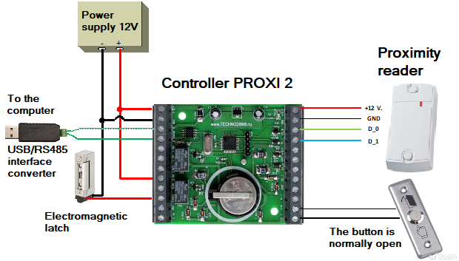

Fig 3. Connection diagram of the DV-PROXY2 AC controller

4.4.1. Controllability check.

To check the DV-PROXY2 AC controller, you must do the following:
1. Connect the controller to a personal computer viaUSB/RS485 interface converter;
2. Apply 12V supply voltage to the controller.
3. Launch the DIVISION Controllers program on your computer.
4. In the “COM Port” window, select the desired port (to which the interface converter is connected) or use the “Auto Search” menu item and click the “Device Search” button. A working and correctly connected device responds immediately; if there is no response, check that lines A and B of the RS-485 interface are connected correctly.
When delivered by the manufacturer, the device is set to address 01. To record a new personal address, you need to click the “Set address” button in the program, select the set address in the drop-down menu, for example 9, click “Write address”. After recording the address, you need to search the device again to make sure that the device responds to the newly set personal address. Any address from 1 to 235 can be used.

4.4.2. Recording access cards into the controller memory using a computer.

In order to write new card codes into the controller memory, you mustthe following equipment:
- DC source 12V, 1A;
- USB/RS485 interface converter;
- PROXYmity card reader with WIGAND 26 interface;
-several pieces of Em-Marine type cards or keychains;
- personal computer with Windows 7 or higher;
- DIVISION Controllers testing and addressing program.
-connecting wires.
For srecording access cards to the controller memoryDV-PROXY2 ACusing a computeryou need to do the following:
1. Connect the reader to the controller (see Figure 2)
2. Connect the controller to a personal computer usingUSB/RS485 interface converter;
2. Apply 12V supply voltage to the controller.
3. Launch the DIVISION Controllers program on your computer.
4. Take one card and bring it to the reader. Then you need to click the “Read data” button in the program window. If the card code is successfully read, you will see the read card code in the text field.
5. Select the type of card; to do this, click on the “Permanent card” mark.
6. Select the memory area in which the card will be written - you need to enter a number from 1 to 1000 in the text field “Indicate the number of the cell in which you want to write or delete” and click the “Write card” button.
7. To check that the card has been successfully written to the controller’s memory, you should bring the same card to the reader again. If the recording is successful, relay No. 2 (lock control relay) will close for 1 second.
For subsequent recording of cards, the algorithm of actions is repeated (items 1-7), while only the number of the memory cell (from 1 to 1000) in which the card code is written is changed in order to avoid overlaps when recording cards.
In order to view in which memory cells of the controller the cards are recorded, you need to click on the button in the “Extract data” program window, while inIn the program window you can see the data of the recorded keys in the controller’s memory.
4.5. Operating mode as part of the DIVISION AC system

The controller can work as part of the DIVISION AC time and attendance system.The process of recording cards into the controller occurs using the DIVISION AC system during the formation of the Database of employees and guests. For more information, please read the DIVISION AC system description.
The operating logic of the controller is determined by installing or removing the jumper on pins 4-5 of the XS1 connector (see section 4.1.).

4.6. Autonomous operation mode.

In standalone mode (without connecting to a computer), you can record incontroller memory up to 1000 manual access card codes. To manually record cards into the controller's memory, you will need a card that acts as a “master card”. In its original state, when supplied by the manufacturer, the controller is supplied without a recorded “master card”. The first card, the code of which is manually written into the controller’s memory, is automatically determined as a “master card”. The “master card” is written once and is not overwritten further. If you lose your master card manually, it is impossible to write down the codes of new cards or erase the codes of old ones.
ATTENTION! The master card code can be erased from the controller’s memory only at the manufacturer’s facility, andthe controller will work with all previously recorded cards.
To record cards into the controller’s memory in manual mode, it is necessary that at least one PROXYmity card (key fob) reader that supports the Wigand 26 protocol is connected to it.
There are 2 LEDs on the controller board: red and green. Red is used to indicate the presence of 12V power. Green - to indicate key code recording modes, and when working as part of the DIVISION AC time and attendance system - to indicate communication with the central controller (computer).

4.6.1. Entering key card recording mode.

To enter the key card recording mode you must:
1. turn off the power to the DV-RPOXI2 AC controller;
2. close pins 3-4 of the XS1 connector with a jumper (see Figure 2);
3. supply 12V power to the controller;
4. after the green LED on the controller lights up, you need to remove the jumper;
5. wait (about 10 seconds) until the green LED on the controller begins to turn on and off. If the on/off interval is 1 second (“slow interval”), this means that the controller has entered the “key card writing” mode and cards can be added to the controller’s memory. If the LED turns on and off with an interval of 0.25 seconds. (“fast interval”), this means that the “master card” has not yet been written to the controller’s memory and the controller has switched to the “master card recording” mode.

4.6.2. Recording a “master card”.

Bring the card that will be recorded as a “master card” to the reader, the LED will change its blinking rate by 0.5 seconds (“middle interval”), bring the card to the reader again, the LED will go out and after a while will go into blinking mode with at an interval of 1 second - the “Master Card” is recorded.
Upon completion of the “master card” recording, the controller automatically switches to the key card recording mode.

4.6.3. “Record key cards” mode.

In this mode, the green LED turns on and off at 1 second intervals. Bring the “master card” to the reader, the LED will change its blinking rate for 0.5 seconds. Bring the card to the reader, the code of which needs to be written into the controller’s memory, the LED will change its blinking rate for 0.25 seconds. Once again, bring the card being written to the reader, the LED will go out and after a short time will return to a flickering interval of 1 second - the card has been written.
The process for recording subsequent cards is similar: first you need to present the “master card”, then twice in turn present the new card to be recorded.
ATTENTION!If you lose your master card manually, it is impossible to write down the codes of new cards or erase the codes of old ones.The master card code can be erased from the controller’s memory only at the manufacturer’s facility, andthe controller will work with all previously recorded cards.

4.6.4. “Erase cards” mode.

To erase key cards or clear all controller memory, you will need a recorded “master card”.To enter the erase mode, while in the “key card writing” mode (see section 4.6.3.), close pins 4-5 of the XS1 connector with a jumper (see Figure 2). Then wait (for 10 seconds) until the VS2 LED on the controller begins to turn on and off at 0.5 second intervals.
To erase a recorded key card from the controller’s memory, bring the “master card” to the reader, the LED will change its blinking rate for 0.25 seconds, then bring the card that needs to be erased from the controller’s memory to the reader. The LED will go out and after a short time will switch to a flickering interval of 0.5 seconds - the card has been erased from the controller’s memory, you can erase the next card. To erase the next recorded key card from the controller’s memory, you must first present the “master card” again, and then the card to be deleted.
To erase the entire memory of the controller, bring the “master card” to the reader, the LED will change its blinking rate for 0.25 seconds. Bring the “master card” to the reader again, the LED will light up constantly. The memory erasing process takes apPROXYmately 2 minutes. While the LED is on, you cannot turn off the power to the controller (otherwise the memory may not be completely cleared). Upon completion of the memory erasing process, the LED will change its blinking rate for 0.5 seconds. The controller memory has been cleared.ATTENTION! Master card in progresserasing all controller memorydoes not erase!
To exit the “erase cards” mode and return to the “write key cards” mode, you need to remove the jumper that closes pins 4-5 of the XS1 connector.
4.6.5. Features of recording maps in manual mode.

If you try to write a previously recorded card into the controller’s memory, the controller will close for 1 second. the lock relay R2 will again switch to the “key card writing” mode, but the card will not be written again.
If you try to write a “master card” as a regular card, the controller will switch to the “write key cards” mode, but no recording will be made.

5.Operating the controllerDV-PROXY2 AC.

ForOperation of the DV-PROXY2 AC controller requires the following equipment:
- DC source 12V, not less than 1.2A;
- USB/RS485 interface converter;
- PROXYmity card readerEM-Marinewith WIGAND 26 interface;
-several pieces of Em-Marine type cards or keychains;
-connecting wires.
The connection diagram for the DV-PROXY2 AC controller in the DIVISION AC system (hotel room controller) is shown in Figure 4.

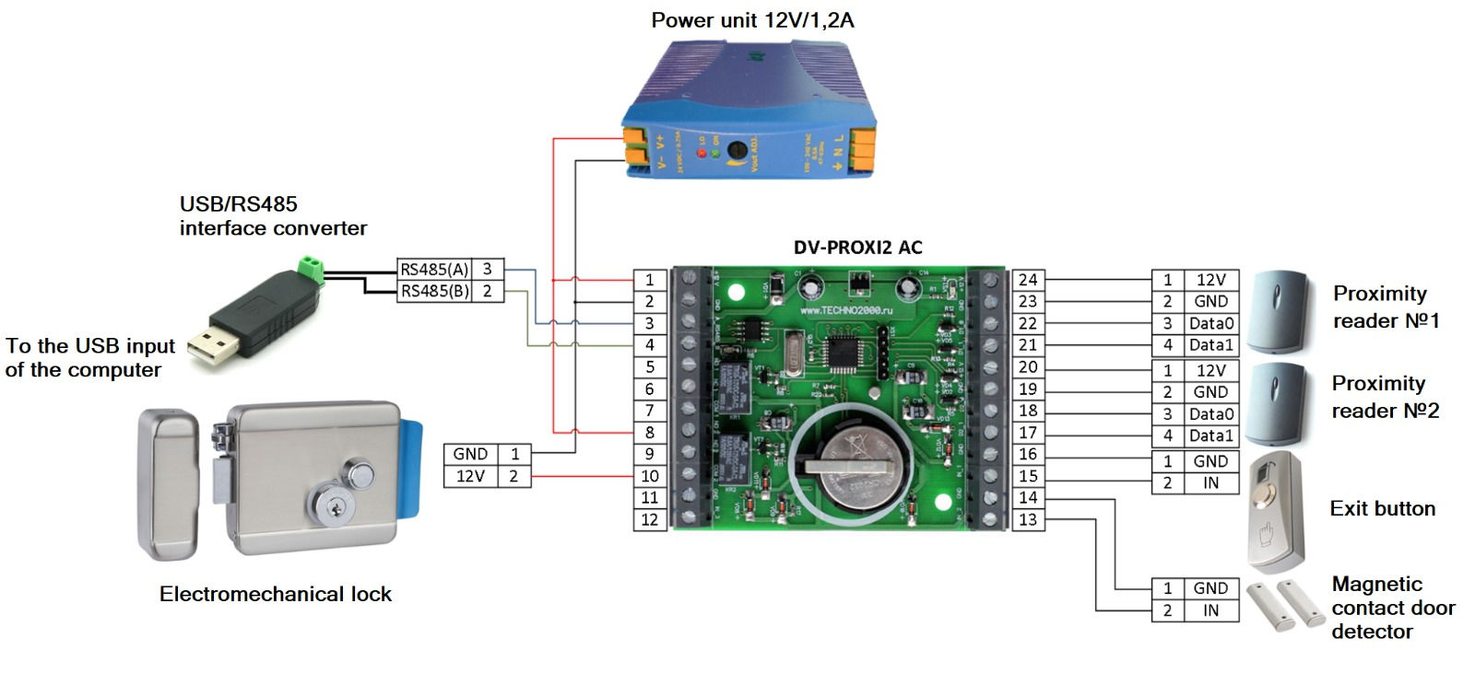
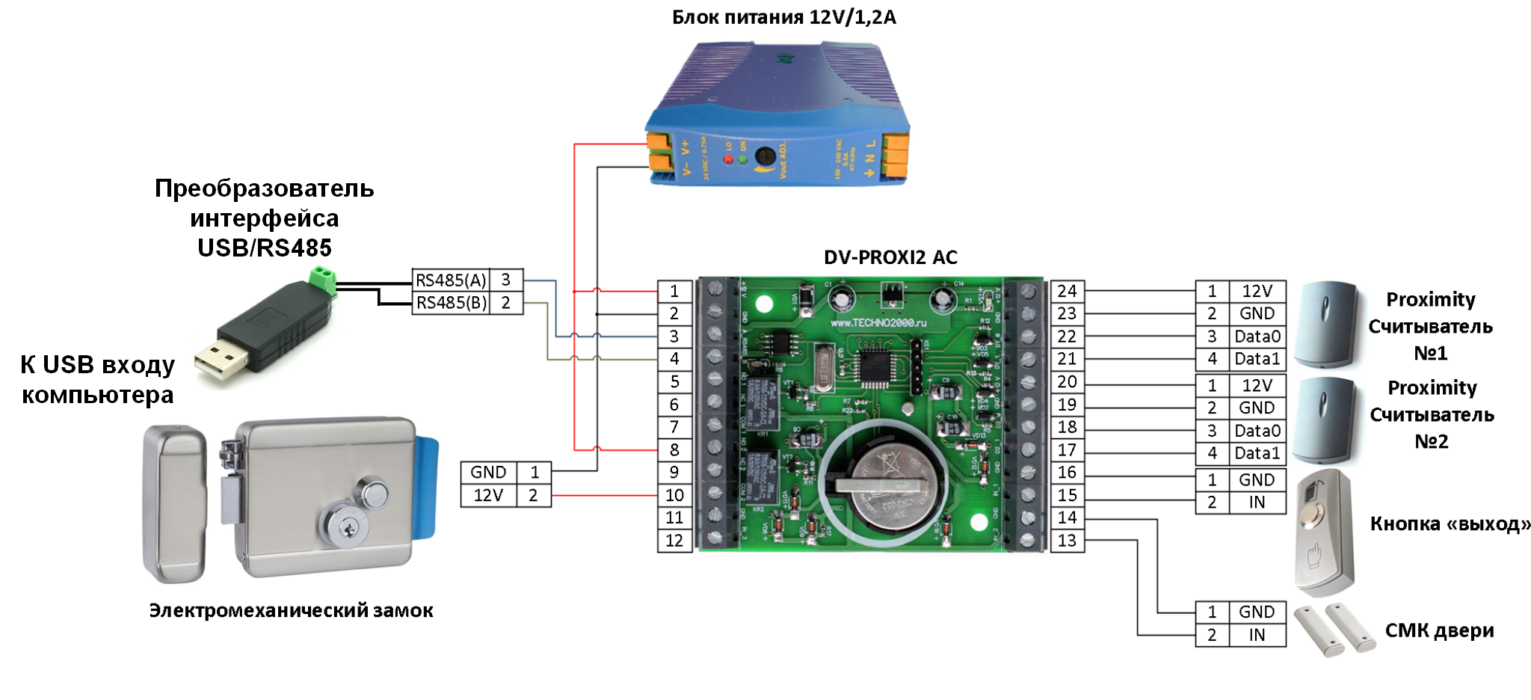
Fig. 4Connection diagram of the DV-PROXY2 AC controller in the DIVISION AC access control system

6.Maintenance.

Maintenance of the DV-PROXY2 AC controller is carried out according to a scheduled preventative system. Maintenance work includes:
– checking the external condition of the device;
– performance check according to this manual;
– checking the reliability of the module fastening, the condition of external mounting wires and contact connections.

7. Storage.

Module storage temperature range from -40⁰From up to +500С.
When storing the module in rooms with a negative temperature range, it is necessary to keep the device at room temperature (+20^{0C).}
The storage rooms for the module should not contain vapors of acids, alkalis, corrosive gases and other harmful impurities that cause corrosion.

8. Manufacturer's warranty.

The manufacturer guarantees the operability of the device if the consumer complies with the rules of transportation, storage, installation and operation.
The warranty period is 36 months from the date of commissioning, but not more than 40 months from the date of shipment.
When sending a product for repair, it must be accompanied by a report describing the possible malfunction.

9. Manufacturer information

LLC "DVC Technologies"
Website: http://www.division.business

10. Certificate of acceptance and packaging.
ModuleDV-PROXY2 ACmanufactured andaccepted in accordance with the current technical documentation, declared fit for use and packaged by DVC Technologies LLC.
Responsible for receiving and packaging
Quality Control Department
MP _____________________________ _____________________________
FULL NAME. year, day, month

